Sizing DNA on an agarose gel

This assignment is due by 07/03/2017. Late submissions will be penalized (25% deduction/day). This assignment is worth 15 points. This assignment may not be submitted electronically.

Agarose gel electrophoresis can also be used to determine the size of a particular DNA fragment. Whenever this technique is performed, a molecular size marker (also called DNA Ladder) is used as a standard. The ladder contains DNA fragments of known size. Since these fragments travel down the gel according to their size, a standard curve of the distance traveled vs. fragment size can be drawn for the DNA fragments of the ladder. Scientists can then use that standard curve to estimate the size of unknown DNA fragments.

In this assignment you will:
- Create a standard curve of DNA ladder fragments and their migration distance by graphing the given data.

- Estimate the size of unknown DNA fragments using the standard curve

Build the standard curve:
- Using the gel represented in Figure 1 measure the distance traveled (in millimeters) by each fragment in the DNA ladder (Lane 1). Start measuring from the center of the well (open rectangle) and measure the distance to the center of each band. Enter your data in Table 1.

- Plot the length of each fragment on the Y axis versus distance traveled on the X axis. Use the graph provided.
  - fragment length is measured in base pairs or bps
  - distance traveled is measured in millimeters or mm
  - Y axis is the vertical axis
  - X axis is the horizontal axis

- Draw a best fit curve. To do this, draw a smooth curve * that best estimates the plotted data. Do not just connect the dots. It is ok if your curve misses some of the data to maintain a smooth curve.

Estimate the size of unknown DNA fragments:
- The unknown DNA fragments are in Lanes 2 to 4. Measure the distance traveled by each unknown the same way you did for the Ladder. Record your data in Table 2.

- Use your standard curve to estimate the size of the unknown fragments (In lanes 2, 3 and 4).
  - Mark the distance traveled by each unknown fragment on the X axis. From each point, draw a line up until your line touches the standard curve, then make a horizontal line over to the Y axis. This will give you the size of the fragment of interest. (show your work on the curve)

Please submit only your report page (your standard curve as well as Tables 1 and 2). Your report must be neat. Points will be deducted for sloppiness.

Figure 1: Agarose gel with DNA Ladder in Lane 1, and unknown DNA fragments in Lane 2-4. Empty boxes are the wells, the solid bands are the DNA fragments after electrophoresis. Take measurements in millimeters (mm).

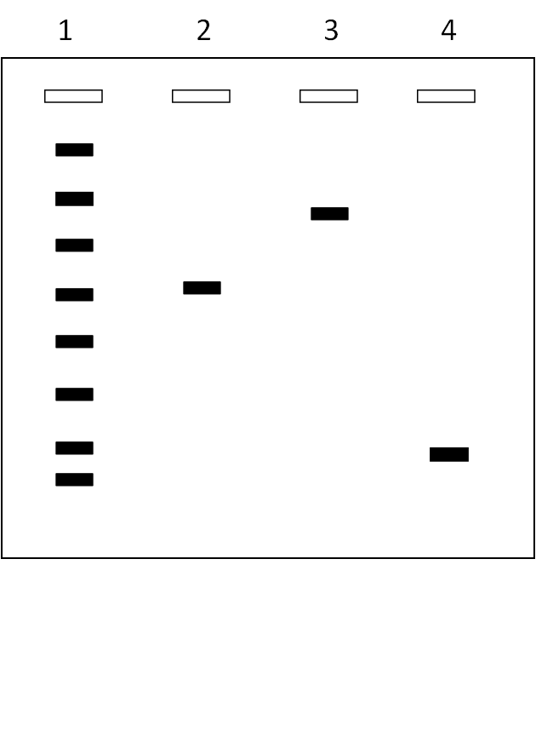
Example of a smooth curve
**

Report Page Name:

Table 1. Distance traveled by the fragments of the DNA Ladder (Lane 1).
Molecular weight marker  fragment size (bp) | Distance traveled by the fragments (mm)
2,000
1,500
1,000
750
500
300
150
50

Table 2. Distance traveled by the fragments in lanes 2 to 4.

Lane | Distance traveled by the fragments (mm) | Size of the fragments  (bp)
2
3
4

Standard Curve:

